**Module 4 Challenge: Pandas**

* **Overview of the school district analysis**: The project included an analysis of fifteen district school’s data. This data included information regarding the school’s type, size, budget along with information about the students with their grades, reading score, math score and the school that students go to. With the help of Pandas, an analysis was carried to achieve to outputs: 1. Replace ninth grade reading and math scores due to academic dishonestly and 2. Conduct a school district analysis.
* **Results of the Analysis**:

1. How is the district summary affected? *The district summary after replacing the ninth grade reading and math scours due to academic dishonestly, the new data shows following changes: a. % Passing Math changed from 75% to 74.80$ b. % Passing Reading changed from 86% to 85.70% and c. % Overall Passing changed from 65% to 64.90%.*



1. How is the school summary affected? *The schools data showed a significant drop in their scores of math and reading grade and the overall passing percentage.*
2. How does replacing the ninth graders’ math and reading scores affect Thomas High School’s performance relative to the other schools? *The average math score and average reading score shows minor change following the replacement of the scores. However, % passing reading, % passing math and % overall passing dropped significantly after replacement of the score.* 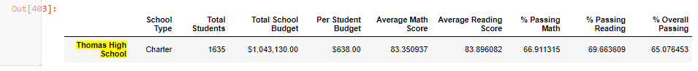
3. How does replacing the ninth-grade scores affect the following:
   1. Math and reading scores by grade: *Following the replacement the overall passing percentage in math and reading dropped.*
   2. Scores by school spending: *The overall average of reading and math score remained the same. However, the percentage of math and reading grade and the overall passing percentage in math and reading dropped in the where the spending per student was in the range of $630 to $675.* Table

      Description automatically generated
   3. Scores by school size: *A change was only observed in the medium size schools where the student size was in the range of 1000-2000. The data of small and large size schools remained unchanged.* Table

      Description automatically generated
   4. Scores by school type: *A change was observed in the Charter schools where the percentage of math and reading score dropped along with the overall passing percentage. The data of District schools remains unchanged following the replacement.* Graphical user interface, text, application

      Description automatically generated

* **Summarizing four changes:** *The four major changes were observed in the data after replacing the math and reading score. Following the replacement, there was a deviation in the percentage of math score, percentage of reading score and overall passing percentage. This deviation led to major changes like a. a medium school had a drop in its score percentage, b. the student’s budget of more than $650.00 had the most deviation in the score following the replacement, c. the overall grades and the score averages dropped after the replacement scores, d. Thomas High School’s average percentage of grades dropped following the replacement of the scores.*